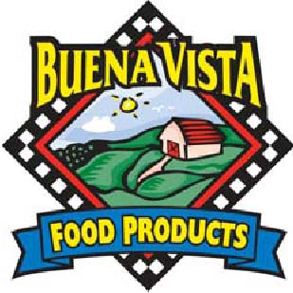

SW Scramble, 3.75 oz, #55120 IW, #55110 Bulk

Nutrition Facts | Total Fat 10 g 15% Total Carbohydrate 31 g 10%  Sat Fat 3.5 g 18% Fiber 1 g 4%  Trans fat 0 g Sugars 3 g  Cholesterol 105 mg 35% Protein 11 g  Sodium 480 mg 20%
Amt/Serving size; 3.75 oz
(106 grams)
Servings per unit: 1
Calories 260
Calories from Fat 90
Vit A – 6% * Vit C – 100% * Calcium – 10% * Iron – 10%
Ingredients:

Enriched Wheat flour (wheat flour, malted barley flour, niacin, iron, ThiAmin Mononitrate, riboflavin, folic acid, ascorbic acid added as conditioner), Scrambled Eggs (Whole Eggs, Non Fat Milk, Soybean Oil, Modified Food Starch, Salt, Xanthan Gum, Citric Acid, Butter Flavor [Maltodextrin, Natural Butter Flavor, Annatto, Tumeric (added for color)], Pepper), WATER, CHEDDAR Cheese (Cultured Pasteurized Milk, Salt, Enzymes, Coloring If Needed), POTATOES (POTATOES, CANOLA AND COTTONSEED OIL, SALT, DEHYDRATED ONION, DEXTROSE, SODIUM ACID PYROPHOSPHATE (MAINTAINS NATURAL COLOR), CORN STARCH-MODIFIED), Salsa (Red Tomatoes, Water, Tomato Sauce, Onions, Jalapeno, Cilantro, Salt, Citric Acid), BLEND OF CANOLA AND OLIVE OILS, CONTAINS 2% OR LESS OF: SUGAR, Jalapeno Peppers (Sliced Jalapeno Peppers, Water, Vinegar, Salt, Calcium Chloride), YEAST, Soy Lecithin, DEXTROSE, whey, Ascorbic Acid, Dough Conditioner (Whey (Milk), L-Cysteine Hydrochloride), SALT

CONTAINS: Milk, egg, SOY, WHEAT

Bread Servings: (106 x .38) = 2.73 Breads (rounds down to 2.5 Breads)
Cheese Servings: (3.75 x 0.047) = .17 servings
Egg Servings: (3.75 x .236)/1.7 = .52 servings
Total Meat alternate servings per breakfast empanada = .69 servings (rounds down to 0.5)

Breads | Fruit/Vegetable | Protein
2.5 | Na | .5

I certify that the above information is true and correct.
6/1/2011 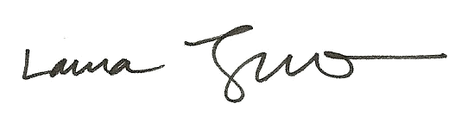
Date Laura Trujillo, RD, SNS

